**Rational Number Scavenger Hunt**

**Outcome:** Grade 8 N06 - Students will be expected to demonstrate an understanding of multiplying and dividing positive fractions and mixed numbers, concretely, pictorially, and symbolically.

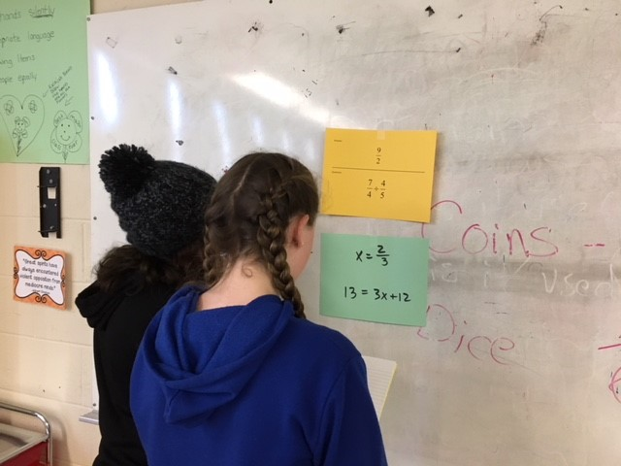**Instructions:** Math questions are posted on the walls around the room. Students create a small group and find a question.  After solving that question, students pick look around the room to find the poster with that answer at the top. Now, students solve the new question at the bottom of that page and the process continues until they find their way back to their starting poster. Each group can start at any poster.

Answer:



Question:



Answer:



Question:



Answer:



Question:



Answer:



Question:



Answer:



Question:



Answer:



Question:



Answer:



Question:



Answer:



Question:



Answer:



Question:



Answer:



Question:

