**Rational Number Operations Question Stack**

**Outcome:** Grade 8 N06 - Students will be expected to demonstrate an understanding of multiplying and dividing positive fractions and mixed numbers, concretely, pictorially, and symbolically.

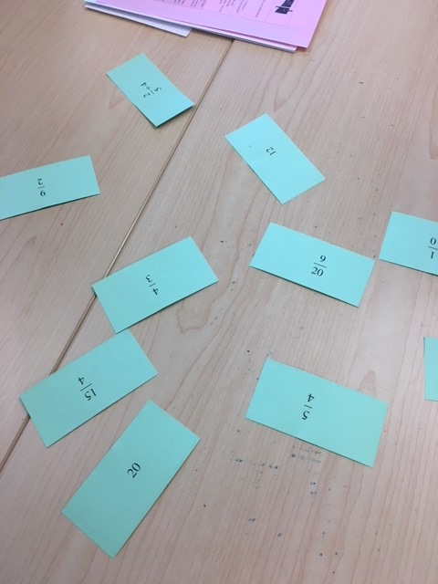**Instructions:** Students start by laying out all the cards with the answers facing up.  This is the group's answer bank.  Students flip over a single card.  This is the start of their "question stack" and their first question to solve.  After solving that question, students pick up the corresponding question card and place it on top of the question card they just solved.  The question and answer should now be facing each other. Now, students solve the new question and the process continues until they have worked through all the cards.

|  |  |
| --- | --- |
|  |  |
|  |  |
|  |  |
|  |  |
|  |  |
|  |  |
|  |  |
|  |  |
|  |  |
|  |  |