- Shade part of the image below.  - Find out what fraction of the image you shaded.  - Record the fraction at the bottom of the image  - Hang your fraction on the number line in the correct spot. | - Shade part of the image below.  - Find out what fraction of the image you shaded.  - Record the fraction at the bottom of the image  - Hang your fraction on the number line in the correct spot. | - Shade part of the image below.  - Find out what fraction of the image you shaded.  - Record the fraction at the bottom of the image  - Hang your fraction on the number line in the correct spot.
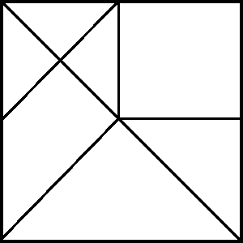  Fraction Shaded:  _______ | Fraction Shaded:  _______ | Fraction Shaded:  _______

